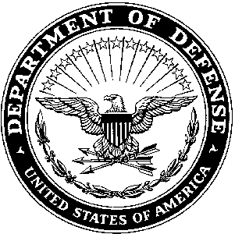AFRC-TNC-G7 05 October 2017

MEMORANDUM FOR RECORD

SUBJECT: Notification for Lack of Required Clothing/ Equipment to Attend the United States Army Drill Sergeant Academy.

1. SGT Kennedy, Jacob M. is scheduled to attend the United States Army Drill Sergeant Academy and does not have in his possession the IOTV/ESAPI PLATES, WEAPONS CLEANING KIT and 7 MAGAZINES. The Reserve TDA does not allow for the issue of these items. Thanks for your understanding and cooperation.
2. Point of Contact is the undersigned at (704)227-2820 EXT: 5191 or [jonathan.d.wray.mil@mail.mil](mailto:jonathan.d.wray.mil@mail.mil)

JONATHAN D WRAY

MAJ, USAR

Individual Training Branch